Power Bi Dashboard

* The Dashboard consists of two pages

1. Customers by region and state (Here we have a wide look of customer count by state and unique customers, this gives an idea of customer distribution from 2020 and 2021. Please select year filter and region filter to know more about the data slicing and partitions.)
2. A sales dashboard (Here we have a wide look of sales count and sales value> along with total sales value and discount percent and along with it has lot of filters for slice dicing the data.)

1 Customers by region and state>>>> South has lot of customer base.

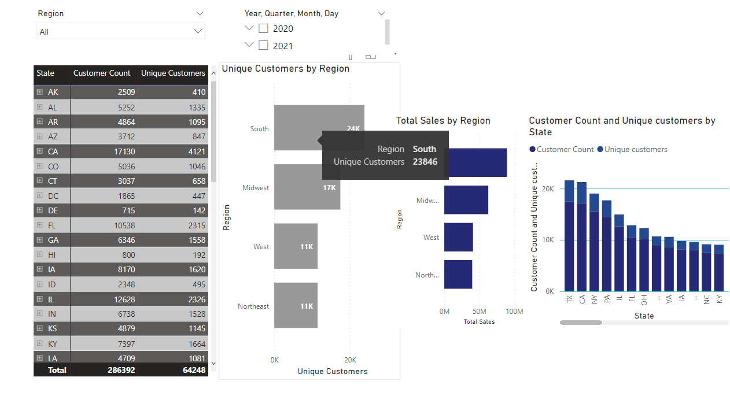

2 A sales dashboard

